‘DrumPad’ by Graham Lambe

Student Number 16432016 – 19th December 2016

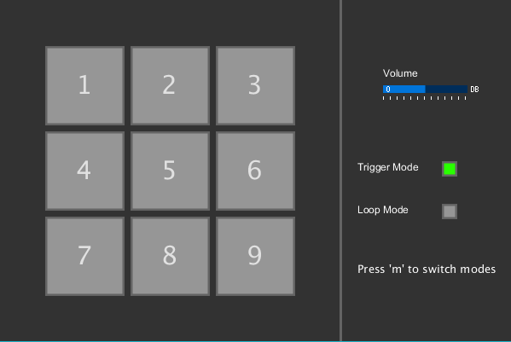

Introduction

As You can see above, I have coded a program which allows sounds to be played by pressing numbers on the keyboard. It is around 600 lines of code and uses mainly the minim library. The minim library is an add-on to Processing 3.0 that allows you to play and manipulate audio. It is very useful for many programmers and is popular with Arduino coders. The aim of the project was to create an aesthetically pleasing Synthesizer pad that has two modes, ‘Trigger Mode’ which plays an audio clip once, and ‘Loop Mode’ that repeatedly plays an audio clip.

Specification

The program is designed to play 9 Audio Clips from the song ‘Destination Calabria (Firebeats Remix) in user provided order. Upon pressing a key in ‘Trigger Mode’ the selected audio clip should play once. In ‘Loop Mode’ it will play continuously until the user presses the number key again to stop it. It also has a volume slider which adjusts the gain of all audio clips played. There is also an indicator to which mode the program is currently in. The program should run on all hardware and is not very hard to run. The only requirements the program has is an audio output, as without this the program would be useless.

Overview of Code:

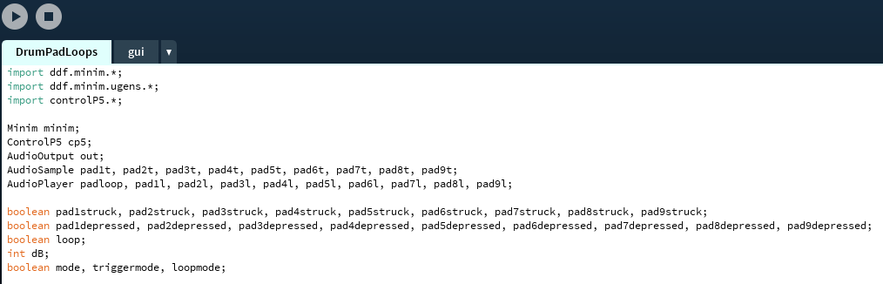

Above is a snippet from the code of my program. It shows the vast amount of Booleans needed for every button. You can also see that there is a ‘gui’ tab, which void draw() is contained in.

. 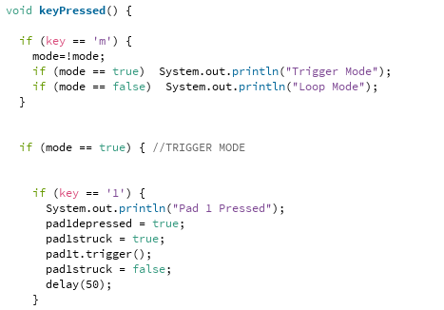

This snippet of code is using the ‘keyPressed()’ function. As you can see, I used a Boolean to determine the ‘mode’ of the program (trigger/loop). The functionality for trigger mode Pad 1 is also included. Upon pressing one, “Pad 1 Pressed” is sent to the console, ‘pad1depressed’&’pad1struck’ are set to true, while ‘pad1t; is triggered. I named all trigger pads with a ‘t’ at the end for ease of coding. After triggering, pad1struck is set back to false. This was to allow an easy way to show a virtual press of a button, although was not used in the final gui. Instead, ‘pad1depressed’ was used as seen below.

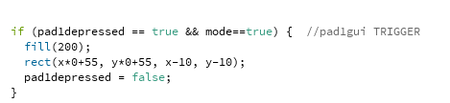

Above is the GUI for Pad 1. Upon pad1depressed becoming true, and being in Trigger Mode (mode==true), Pad 1’s box is filled with a lighter grey than before. This simulates the press of a button on a screen. I used x and y as an easy way to draw the original GUI and also as a way to fill the buttons.

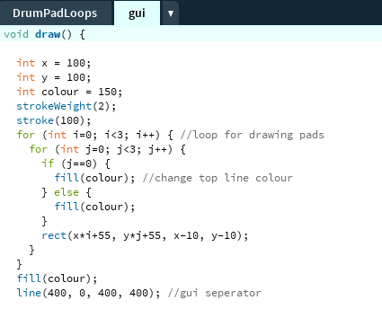

This is the loop I used to draw the pads, Using a nested array and a ‘x’ and ‘y’ variable I was able to easily draw a 3x3 grid of squares on the screen. Also included is the functionality to change the top line colour. This is unused in the final project as I did not find the need for it.

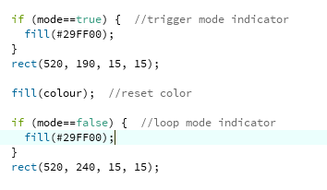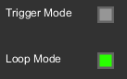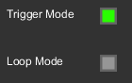

This is the indicator used to display the mode of the program. I chose the colour green as it is a universal indicator for ‘on’ and will not confuse the user. I could have used a grey colour and kept the colour swatch of the program, although I believed it could confused the user and thus did not do so.

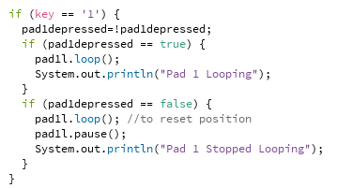

Above is the functionality for the ‘Loop Mode’ of Pad 1. As you can see, the lighter shade signifies ‘pressed’ and the darker shade signifies ‘depressed’. The functionality for this change in shade is seen below. I also used the text function to put the number 1 on the pad, to allow users to understand that pressing number 1 will trigger this pad.

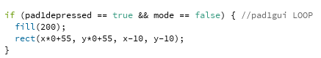

I also used the ‘ControlP5’ Library to create a slider to allow me to easily control the Volume. Using ‘.addSlider’ and Minim’s control of ‘gain’ I was able to link the slider to volume outputted. Below is the code that was used to create the slider.

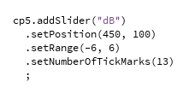

Conclusion

In short, this project was very fun to make. I struggled with the idea at first and wanted to do something different. I tried to create a 16-beat synthesizer, but it proved too difficult so I came up with the idea of a Drum Pad. To improve this project, I could have added mouse functionality but it would have been too awkward to control using a mouse and believe a physical keyboard would work better. The most difficult part of the project was deciding if I wanted a One press one play Drum Pad (Trigger Mode), or a looping one. In the end, I coded both with an easy switch between them.

Bibliography

Minim Library

ControlP5 Library

Minim Examples

ControlP5 Examples

Destination Calabria (Firebeat’z Remix)

Audacity (To split audio files)

End Statement

I have not included any other authors of code above, this is because all code written is of my own work. I preferred in this case to use what I learned from CS171 and put it into practice rather than use another authors work to compliment my project. If you have any questions about my project or code please do not hesitate to email me at graham.lambe.2017@mumail.ie